

**VIVEKANANDA INSTITUTE OF PROFESSIONAL STUDIES - TECHNICAL CAMPUS**

**Grade A++ Accredited Institution by NAAC**

NBA Accredited for MCA Programme; Recognized under Section 2(f) by UGC;

Affiliated to GGSIP University, Delhi; Recognized by Bar Council of India and AICTE

An ISO 9001:2015 Certified Institution

# SCHOOL OF ENGINEERING & TECHNOLOGY

**B.Tech Programme: Computer Science & Engineering**

**Course Title: Operating Systems Lab**

**Course Code: CIC-359**

**Semester: 5th**

## VISION OF INSTITUTE

To be an educational institute that empowers the field of engineering to build a sustainable future by providing quality education with innovative practices that supports people, planet and profit.

## MISSION OF INSTITUTE

To groom the future engineers by providing value-based education and awakening students' curiosity, nurturing creativity and building capabilities to enable them to make significant contributions to the world.

**INDEX**

|  |  |  |  |  |  |  |  |  |
| --- | --- | --- | --- | --- | --- | --- | --- | --- |
| **S.No** | **EXP.** | **Date** | **Marks** | | | **Remark** | **Updated** | **Faculty** |
|  |  |  |  | | |  | **Marks** | **Signature** |
|  |  |  | **Laboratory** | **Class** | **Viva** |  |  |  |
|  |  |  | **Assessment** | **Participation** | **(5 Marks)** |
|  |  |  | **(15 Marks)** | **(5 Marks)** |  |
| 1. | Write a program to implement CPU scheduling for first come first serve. |  |  |  |  |  |  |  |
| 2. | Write a program to implement CPU scheduling for shortest job first. |  |  |  |  |  |  |  |
| 3 | Write a program to implement CPU scheduling for Round Robin. |  |  |  |  |  |  |  |
|  |  |  |  |  |  |  |  |  |
|  |  |  |  |  |  |  |  |  |

**INDEX**

|  |  |  |  |  |  |  |  |  |
| --- | --- | --- | --- | --- | --- | --- | --- | --- |
| **S.No** | **EXP.** | **Date** | **Marks** | | | **Remark** | **Updated** | **Faculty** |
|  |  |  |  | | |  | **Marks** | **Signature** |
|  |  |  | **Laboratory** | **Class** | **Viva** |  |  |  |
|  |  |  | **Assessment** | **Participation** | **(5 Marks)** |
|  |  |  | **(15 Marks)** | **(5 Marks)** |  |
| 6 | Write a program to implement first fit, best fit and worst fit algorithm for memory management. |  |  |  |  |  |  |  |
| 7 | Write a program to implement reader/writer problem using semaphore. |  |  |  |  |  |  |  |
| 8 | Write a program to implement Producer-Consumer  problem using semaphores. |  |  |  |  |  |  |  |
| 9 | Write a program to implement Banker’s algorithm for  deadlock avoidance. |  |  |  |  |  |  |  |
| 10 | Write C programs to implement the various File  Organisation Techniques |  |  |  |  |  |  |  |

**PROGRAM 1**

**PROBLEM STATEMENT: Write a program to implement CPU scheduling for first come first serve.**

**THEORY:**

First-Come, First-Served (FCFS) is one of the simplest and most straightforward CPU scheduling algorithms used in operating systems. It operates on a queue-based mechanism where processes are executed in the order they arrive in the ready queue. This means that the process that arrives first will be the first to get executed, and it will run to completion before the next process starts.

**Basic Operation**

* **Queue Management**: In FCFS scheduling, processes are maintained in a queue, typically a FIFO (First In, First Out) queue.
* **Execution Order**: When the CPU becomes available, the process at the head of the queue is selected for execution.
* **Completion**: A process runs to completion before the next process in the queue starts execution.

**Waiting Time (WT)**: The average waiting time in FCFS is calculated as the sum of the waiting times for all processes divided by the number of processes. It tends to be high, especially if there is a large disparity in process burst times.

**Turnaround Time (TAT)**: The turnaround time is the total time taken from the arrival of a process to its completion. In FCFS, turnaround time can also be high due to the sequential nature of execution.

**ALGORITHM:**

**PROBLEM:**

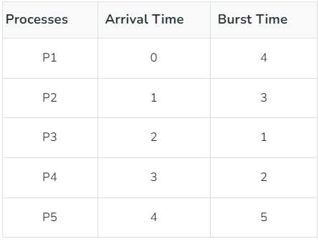

**PROBLEM SOLUTION:**

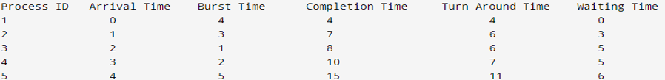

**CODE:**

#include <iostream>

using namespace std;

struct process

{ int PID;

int arrival_time;

int burst_time;

int completion_time;

int turn_around_time;

int waiting_time;

};

void fcfs_scheduling(process processes[],int n)

{ int current_time=0;

for(int i=0;i<n;i++)

{ processes[i].completion_time = current_time + processes[i].burst_time;

processes[i].turn_around_time = processes[i].completion_time - processes[i].arrival_time;

processes[i].waiting_time = processes[i].turn_around_time - processes[i].burst_time ;

current_time+= processes[i].burst_time;

}

}

void print_processes_data(process processes[],int n)

{ cout<<"Process ID \t Arrival Time \t Burst Time \t Completion Time \t Turn Around Time \t Waiting Time"<<endl;

for(int i=0;i<n;i++)

{ cout<< processes[i].PID<<"\t \t \t \t"<< processes[i].arrival_time<<"\t \t \t \t"<<processes[i].burst_time<<"\t \t \t \t"<<processes[i].completion_time<<"\t \t \t \t \t \t"<<processes[i].turn_around_time<<"\t \t \t \t"<<processes[i].waiting_time <<endl;

}

}

int main()

{int n;

cout<< "Enter no of processes:" ;

cin >> n;

process processes[n];

for(int i=0;i<n;i++)

{ cout << "Enter Process ID:" <<endl;

cin >> processes[i].PID;

cout << "Enter Process Arrival Time:" <<endl;

cin >> processes[i].arrival_time;

cout << "Enter Process Burst Time:" <<endl;

cin >> processes[i].burst_time;

}

fcfs_scheduling(processes,n);

print_processes_data(processes,n);

return 0;

}

**OUTPUT:**

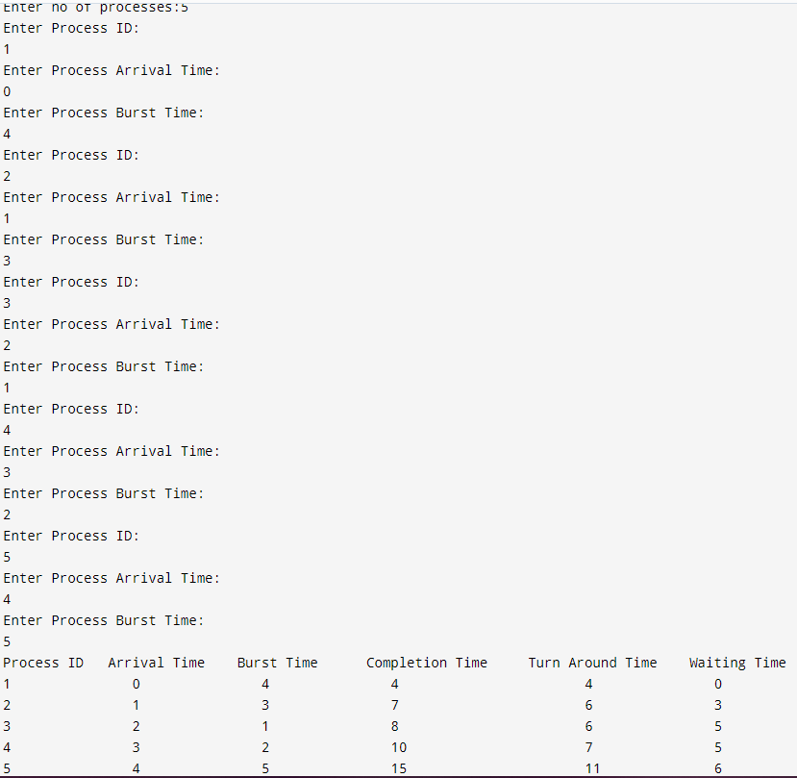

**LEARNING OUTCOMES:**

**PROGRAM 2**

**PROBLEM STATEMENT:** **Write a program to implement CPU scheduling for shortest job first.**

**THEORY: Shortest Job First (SJF)** is a CPU scheduling algorithm that selects the process with the smallest execution (burst) time from the ready queue. It is designed to minimize the average waiting time of processes by prioritizing shorter jobs, which typically leads to better overall system performance. SJF can be implemented in either non-preemptive or preemptive (Shortest Remaining Time First, SRTF) forms.

### Basic Operation

* **Queue Management**: In SJF scheduling, processes are maintained in a ready queue. The key distinction is that the scheduler selects the process with the shortest burst time, not necessarily the one that arrived first.
* **Execution Order**: When the CPU becomes available, the scheduler scans the ready queue and picks the process with the smallest CPU burst. If the system is using preemptive SJF (SRTF), it will interrupt the current process if a new process arrives with a shorter remaining time.
* **Completion**: In non-preemptive SJF, a selected process runs to completion before the next process with the shortest burst time is chosen. In preemptive SJF (SRTF), the running process may be preempted if a shorter job arrives, and the CPU is assigned to the new process.

**ALGORITHM:**

**PROBLEM:**

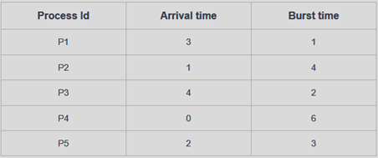

**PROBLEM SOLUTION:**

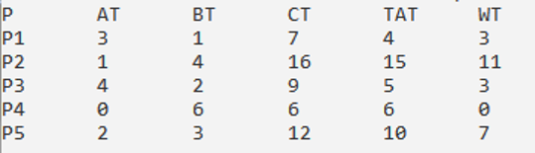

**CODE:**

#include <iostream>

using namespace std;

typedef struct{

int id;

int at; // Arrival Time

int bt; // Burst Time

int ct; // Completion Time

int tat; // Turnaround Time

int wt; // Waiting Time

}process;

int main()

{

int n = 5;

process p[n], q[n];

// Input process details

for(int i = 0; i < n; i++)

{

p[i].id = i + 1;

printf("Enter arrival time and burst time for process P%d: ", i + 1);

scanf("%d %d", &p[i].at, &p[i].bt);

}

// Sort according to arrival time

for (int i = 0; i < n; i++)

{

for (int j = 0; j < n - i - 1; j++)

{

if(p[j].at > p[j + 1].at)

{

process temp = p[j];

p[j] = p[j + 1];

p[j + 1] = temp;

}

}

}

int front = 0, rear = 1;

int time = p[0].at;

q[front] = p[0];

int i = 1;

// Process scheduling simulation

while(i < n || front != rear)

{

time += q[front].bt;

for(int k = 0; k < n; k++)

{

if(p[k].id == q[front].id)

{

p[k].ct = time; // Calculate completion time

break;

}

}

while(i < n && p[i].at <= time)

{

q[rear] = p[i];

rear++;

i++;

}

front++;

// Sort ready queue by burst time for SJF

for(int j = front + 1; j < rear; j++)

{

if(q[front].bt > q[j].bt)

{

process temp = q[front];

q[front] = q[j];

q[j] = temp;

}

}

}

// Calculate Turnaround Time (TAT) and Waiting Time (WT)

for (int i = 0; i < n; i++)

{

p[i].tat = p[i].ct - p[i].at; // TAT = CT - AT

p[i].wt = p[i].tat - p[i].bt; // WT = TAT - BT

}

// Arrange processes according to their original IDs

for (int i = 0; i < n; i++)

{

for (int j = 0; j < n - i - 1; j++)

{

if(p[j].id > p[j + 1].id)

{

process temp = p[j];

p[j] = p[j + 1];

p[j + 1] = temp;

}

}

}

// Print the results

printf("P\tAT\tBT\tCT\tTAT\tWT\n");

for (int i = 0; i < n; i++)

{

printf("P%d\t%d\t%d\t%d\t%d\t%d\n", p[i].id, p[i].at, p[i].bt, p[i].ct, p[i].tat, p[i].wt);

}

return 0;

}

**OUTPUT:**

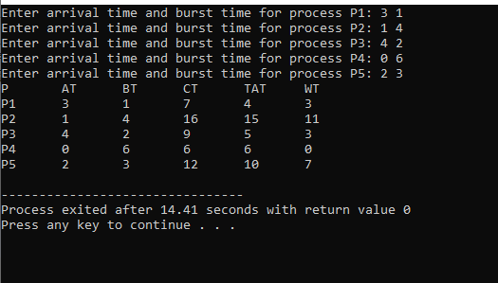

**LEARNING OUTCOMES:**

**PROGRAM 3**

**PROBLEM STATEMENT:** **Write a program to implement CPU scheduling for Round Robin.**

**THEORY:**

**Round Robin (RR)** is a CPU scheduling algorithm designed for time-sharing systems. It is one of the simplest and most widely used scheduling techniques. In this algorithm, each process is assigned a fixed **time quantum** or **time slice** during which it can execute. If a process doesn’t finish within its assigned time quantum, it is preempted and moved to the back of the ready queue, allowing the next process to execute.

### Basic Operation

* **Queue Management**: Processes are maintained in a **FIFO (First In, First Out)** queue. When a process arrives, it is added to the end of the ready queue.
* **Execution Order**: The CPU scheduler picks the process at the front of the queue for execution. The process is allowed to run for a time period equal to the **time quantum**. If the process finishes its execution before the time quantum expires, it is removed from the queue. Otherwise, the process is preempted and placed at the back of the queue, and the next process in line is selected for execution.
* **Completion**: A process continues this cycle of execution and requeueing until it completes. Once a process finishes, it is removed from the system and no longer re-enters the queue.

**ALGORITHM:**

**PROBLEM:**

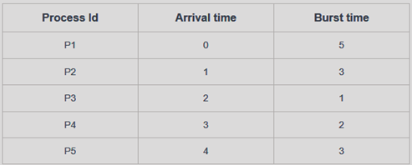

**PROBLEM SOLUTION:**

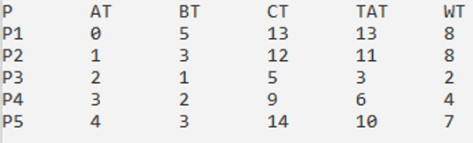

**CODE:**

#include <iostream>

using namespace std;

typedef struct{

int id;

int at; // Arrival Time

int bt; // Burst Time

int ct; // Completion Time

int tat; // Turnaround Time

int wt; // Waiting Time

}process;

int main()

{

printf("Enter number of processes: ");

int n;

scanf("%d", &n);

process p[n], rq[64];

int tq = 2; // Time Quantum

int front = 0, rear = 1;

for (int i = 0; i < n; i++)

{

p[i].id = i + 1;

printf("Enter arrival time and burst time for P%d: ", i + 1);

scanf("%d %d", &p[i].at, &p[i].bt);

}

// Sort processes according to arrival time

for (int i = 0; i < n; i++)

{

for (int j = 0; j < n - i - 1; j++)

{

if (p[j].at > p[j + 1].at)

{

process temp = p[j];

p[j] = p[j + 1];

p[j + 1] = temp;

}

}

}

rq[front] = p[0];

int time = p[0].at;

int i = 1;

while (i < n || front != rear)

{

if (rq[front].bt > tq)

{

time += tq;

rq[front].bt -= tq;

while (i < n && p[i].at <= time)

{

rq[rear] = p[i];

rear++;

i++;

}

rq[rear++] = rq[front]; // Place back in the queue

}

else

{

time += rq[front].bt;

for (int k = 0; k < n; k++)

{

if (p[k].id == rq[front].id)

{

p[k].ct = time; // Set completion time

break;

}

}

}

front++;

}

// Calculate Turnaround Time (TAT) and Waiting Time (WT)

for (int i = 0; i < n; i++)

{

p[i].tat = p[i].ct - p[i].at; // TAT = CT - AT

p[i].wt = p[i].tat - p[i].bt; // WT = TAT - BT

}

// Arrange processes according to their IDs

for (int i = 0; i < n; i++)

{

for (int j = 0; j < n - i - 1; j++)

{

if (p[j].id > p[j + 1].id)

{

process temp = p[j];

p[j] = p[j + 1];

p[j + 1] = temp;

}

}

}

printf("P\tAT\tBT\tCT\tTAT\tWT\n");

for (int i = 0; i < n; i++)

{

printf("P%d\t%d\t%d\t%d\t%d\t%d\n", p[i].id, p[i].at, p[i].bt, p[i].ct, p[i].tat, p[i].wt);

}

return 0;

}

**OUTPUT:**

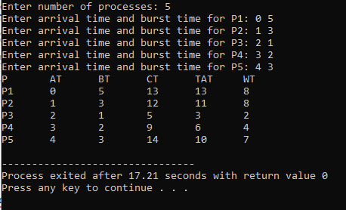

**LEARNING OUTCOMES:**

**PROGRAM - 4**

**PROBLEM STATEMENT** Write a program for page replacement policy using

a) LRU b) FIFO c) Optimal.

**THEORY**

Page replacement algorithms are used in operating systems to manage how **pages** are swapped in and out of memory when a process requires more memory than is available. When a page that is not currently in memory is needed, the operating system selects a page to replace, i.e., remove from memory, to make room for the new one. The goal of these algorithms is to minimise page faults, which occur when the required page is not in memory.

**Common Page Replacement Algorithms:**

1. **First-In, First-Out (FIFO):**
   * The oldest loaded page (the first one loaded into memory) is replaced.
   * Pages are loaded into memory in a queue. When a page needs to be replaced, the page at the front of the queue (the one that has been in memory the longest) is removed.
   * It is simple to implement. However, it does not consider how often or how recently a page was used, leading to possible poor performance (e.g., **Belady’s Anomaly**).
2. **Optimal Page Replacement (OPT):**
   * It replaces the page that will not be needed for the longest period in the future.
   * The algorithm looks ahead to see which pages will be used and replaces the page that will not be needed for the longest time.
   * It guarantees the lowest number of page faults. However, it is not practical for real systems since it requires future knowledge of memory accesses.
3. **Least Recently Used (LRU):**
   * It replaces the page that has not been used for the longest time.
   * The algorithm keeps track of the order in which pages are used. When a replacement is needed, it chooses the page that was least recently used.
   * It approximates the performance of the optimal algorithm and does not suffer from Belady's Anomaly. However, it requires extra overhead to track the order of usage.

**ALGORITHM**

**NUMERICAL**

**Consider a reference string: 4, 7, 6, 1, 7, 6, 1, 2, 7, 2. the number of frames in the memory is 3. Find out the number of page faults respective to:**

**1. Optimal Page Replacement Algorithm**

**2. FIFO Page Replacement Algorithm**

**3. LRU Page Replacement Algorithm Optimal Page Replacement Algorithm**

**FIFO**

|  |  |  |  |  |  |  |  |  |  |  |
| --- | --- | --- | --- | --- | --- | --- | --- | --- | --- | --- |
| **REQUEST** | **4** | **7** | **6** | **1** | **7** | **6** | **1** | **2** | **7** | **2** |
| **FRAME 1** |  |  |  |  |  |  |  |  |  |  |
| **FRAME 2** |  |  |  |  |  |  |  |  |  |  |
| **FRAME 3** |  |  |  |  |  |  |  |  |  |  |
| **HIT/MISS** |  |  |  |  |  |  |  |  |  |  |

**Page Faults in FIFO-**

**OPTIMAL**

|  |  |  |  |  |  |  |  |  |  |  |
| --- | --- | --- | --- | --- | --- | --- | --- | --- | --- | --- |
| **REQUEST** | **4** | **7** | **6** | **1** | **7** | **6** | **1** | **2** | **7** | **2** |
| **FRAME 1** |  |  |  |  |  |  |  |  |  |  |
| **FRAME 2** |  |  |  |  |  |  |  |  |  |  |
| **FRAME 3** |  |  |  |  |  |  |  |  |  |  |
| **HIT/MISS** |  |  |  |  |  |  |  |  |  |  |

**Page Faults in Optimal Page Replacement -**

**LRU**

|  |  |  |  |  |  |  |  |  |  |  |
| --- | --- | --- | --- | --- | --- | --- | --- | --- | --- | --- |
| **REQUEST** | **4** | **7** | **6** | **1** | **7** | **6** | **1** | **2** | **7** | **2** |
| **FRAME 1** |  |  |  |  |  |  |  |  |  |  |
| **FRAME 2** |  |  |  |  |  |  |  |  |  |  |
| **FRAME 3** |  |  |  |  |  |  |  |  |  |  |
| **HIT/MISS** |  |  |  |  |  |  |  |  |  |  |

**FIRST IN FIRST OUT : -**

**CODE**

#include <stdio.h>

void getRefString(int *ref_string, int n)

{

printf("Enter reference string: ");

for (int i = 0; i < n; i++)

{

scanf("%d", &ref_string[i]);

}

}

void fifoPageReplacement(int *ref_string, int n, int frame_size)

{

int hits = 0, page_faults = 0, frame_ptr = 0;

int frame[frame_size];

double hit_ratio, page_fault_ratio;

// initialize frame with -1

for (int i = 0; i < frame_size; i++)

{

frame[i] = -1;

}

for (int i = 0; i < n; i++)

{

int found = 0;

for (int j = 0; j < frame_size; j++)

{

// if page is already in frame

if (frame[j] == ref_string[i])

{

hits++;

found = 1;

break;

}

}

if (found == 0)

{

frame[frame_ptr] = ref_string[i];

page_faults++;

frame_ptr = (frame_ptr + 1) % frame_size;

}

}

hit_ratio = (double)hits / n;

page_fault_ratio = (double)page_faults / n;

printf("Hits: %d\n", hits);

printf("Page Faults: %d\n", page_faults);

printf("Hit Ratio: %f\n", hit_ratio);

printf("Page Fault Ratio: %f\n", page_fault_ratio);

}

int main()

{

int n, frame_size;

printf("Enter size of reference String: ");

scanf("%d", &n);

int ref_string[n];

getRefString(ref_string, n);

printf("Enter frame size: ");

scanf("%d", &frame_size);

int frame[frame_size];

// initialize frame with -1

for (int i = 0; i < frame_size; i++)

{

frame[i] = -1;

}

fifoPageReplacement(ref_string, n, frame_size);

return 0;

}

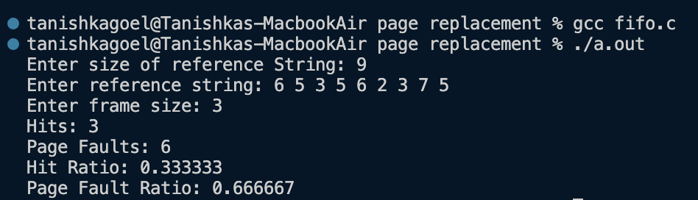

**OUTPUT**

**LEARNING OUTCOMES**

**OPTIMAL PAGE REPLACEMENT**

**CODE**

#include <stdio.h>

void getRefString(int *ref_string, int n)

{

printf("Enter reference string: ");

for (int i = 0; i < n; i++)

{

scanf("%d", &ref_string[i]);

}

}

int findOptimalPage(int *frame, int frame_size, int *ref_string, int n, int current_index)

{

int farthest = current_index;

int replace_index = -1;

for (int i = 0; i < frame_size; i++)

{

int j;

for (j = current_index + 1; j < n; j++)

{

if (frame[i] == ref_string[j])

{

if (j > farthest)

{

farthest = j;

replace_index = i;

}

break;

}

}

if (j == n)

{

return i;

}

if (replace_index == -1)

{

replace_index = i;

}

}

return replace_index;

}

int main()

{

int n;

printf("Enter size of reference String: ");

scanf("%d", &n);

int ref_string[n];

getRefString(ref_string, n);

int frame_size;

printf("Enter frame size: ");

scanf("%d", &frame_size);

int frame[frame_size];

int hits = 0, page_faults = 0;

for (int i = 0; i < frame_size; i++)

{

frame[i] = -1;

}

for (int i = 0; i < n; i++)

{

int found = 0;

// Check if page is already in frame

for (int j = 0; j < frame_size; j++)

{

if (frame[j] == ref_string[i])

{

hits++;

found = 1;

break;

}

}

if (!found)

{

int empty_found = 0;

// Check if there's an empty frame available

for (int j = 0; j < frame_size; j++)

{

if (frame[j] == -1)

{

frame[j] = ref_string[i];

page_faults++;

empty_found = 1;

break;

}

}

if (!empty_found)

{

// Find the page to replace using the optimal policy

int pos = findOptimalPage(frame, frame_size, ref_string, n, i);

frame[pos] = ref_string[i];

page_faults++;

}}}

double hit_ratio = (double)hits / n;

double page_fault_ratio = (double)page_faults / n;

printf("Hits: %d\n", hits);

printf("Page Faults: %d\n", page_faults);

printf("Hit Ratio: %f\n", hit_ratio);

printf("Page Fault Ratio: %f\n", page_fault_ratio);

printf("Final frame state: ");

for (int i = 0; i < frame_size; i++)

{

printf("%d ", frame[i]);

}

printf("\n");

return 0;

}

**OUTPUT**

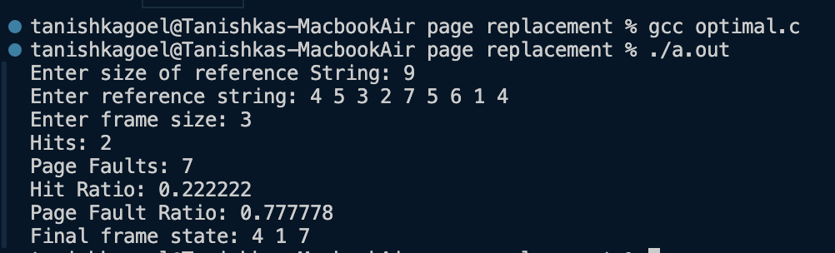

**LRU PAGE REPLACEMENT**

**CODE**

*#include* <stdio.h>

*void* *getRefString*(*int* *\**ref_string, *int* n)

{

*printf*("Enter reference string: ");

*for* (*int* *i* *=* 0; *i* *<* n; *i++*)

{

*scanf*("%d", *&*ref_string[*i*]);

}

}

*int* *findLRUPage*(*int* *\**last_used, *int* frame_size)

{

*int* *min* *=* last_used[0];

*int* *pos* *=* 0;

*for* (*int* *i* *=* 1; *i* *<* frame_size; *i++*)

{

*if* (last_used[*i*] *<* *min*)

{

*min* *=* last_used[*i*];

*pos* *=* *i*;

}

}

*return* *pos*;

}

*int* *main*()

{

*int* *n*;

*printf*("Enter size of reference String: ");

*scanf*("%d", *&n*);

*int* *ref_string*[*n*];

*getRefString*(*ref_string*, *n*);

*int* *frame_size*;

*printf*("Enter frame size: ");

*scanf*("%d", *&frame_size*);

*int* *frame*[*frame_size*];

*int* *last_used*[*frame_size*];

*int* *hits* *=* 0, *page_faults* *=* 0, *time* *=* 0;

*for* (*int* *i* *=* 0; *i* *<* *frame_size*; *i++*)

{

*frame*[*i*] *=* *-*1;

*last_used*[*i*] *=* *-*1;

}

*for* (*int* *i* *=* 0; *i* *<* *n*; *i++*)

{

*int* *found* *=* 0;

*// Check if the page is already in the frame*

*for* (*int* *j* *=* 0; *j* *<* *frame_size*; *j++*)

{

*if* (*frame*[*j*] *==* *ref_string*[*i*])

{

*hits++*;

*found* *=* 1;

*last_used*[*j*] *=* *time++*;

*break*;

}

}

*if* (*!found*)

{

*int* *empty_found* *=* 0;

*for* (*int* *j* *=* 0; *j* *<* *frame_size*; *j++*)

{

*if* (*frame*[*j*] *==* *-*1)

{

*frame*[*j*] *=* *ref_string*[*i*];

*last_used*[*j*] *=* *time++*;

*page_faults++*;

*empty_found* *=* 1;

*break*;

}

}

*if* (*!empty_found*)

{

*int* *pos* *=* *findLRUPage*(*last_used*, *frame_size*);

*frame*[*pos*] *=* *ref_string*[*i*];

*last_used*[*pos*] *=* *time++*;

*page_faults++*;

}

}

}

*double* *hit_ratio* *=* (*double*)*hits* */* *n*;

*double* *page_fault_ratio* *=* (*double*)*page_faults* */* *n*;

*printf*("Hits: %d\n", *hits*);

*printf*("Page Faults: %d\n", *page_faults*);

*printf*("Hit Ratio: %f\n", *hit_ratio*);

*printf*("Page Fault Ratio: %f\n", *page_fault_ratio*);

*printf*("Final frame state: ");

*for* (*int* *i* *=* 0; *i* *<* *frame_size*; *i++*)

{

*printf*("%d ", *frame*[*i*]);

}

*printf*("\n");

*return* 0;

}

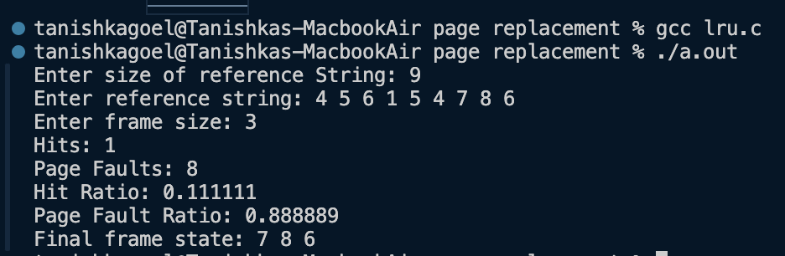**OUTPUT**

**LEARNING OUTCOMES**

**PROGRAM - 5**

**PROBLEM STATEMENT** Write a program to perform priority scheduling.

**THEORY**

Priority scheduling is a CPU scheduling algorithm used in operating systems where each process is assigned a priority. In this algorithm, the CPU is allocated to the process with the highest priority. If two processes have the same priority, they are scheduled based on other criteria, such as first-come, first-served (FCFS).

Priority of processes depends on some factors such as:

* Time limit
* Memory requirements of the process
* Ratio of average I/O to average CPU burst time

***Types of Priority Scheduling Algorithms***

There are two types of priority scheduling algorithms in OS: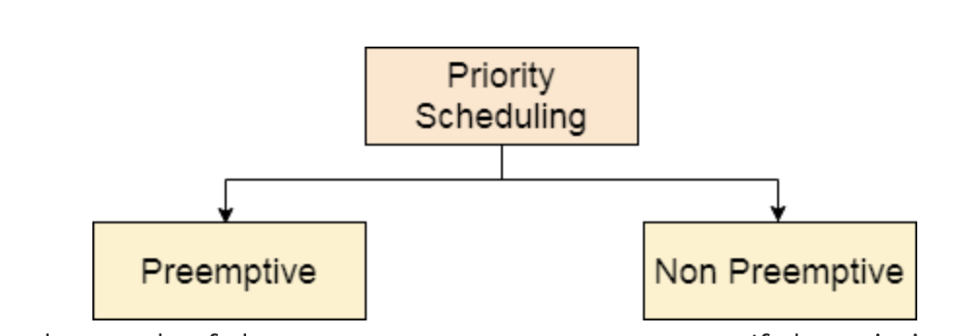

**Non-Preemptive Scheduling**

In this type of scheduling:

* If during the execution of a process, another process with a higher priority arrives for execution, even then the currently executing process will not be disturbed.
* The newly arrived high priority process will be put in next for execution since it has higher priority than the processes that are in a waiting state for execution.
* All the other processes will remain in the waiting queue to be processed. Once the execution of the current process is done, the high-priority process will be given the CPU for execution.

**Preemptive Scheduling**

Preemptive Scheduling as opposed to non-preemptive scheduling will preempt (stop and store the currently executing process) the currently running process if a higher priority process enters the waiting state for execution and will execute the higher priority process first and then resume executing the previous process.

**ALGORITHM**

**NUMERICAL**

**Consider the set of 5 processes whose Arrival Time, Burst Time and Priority is given. Calculate the average Turnaround Time and Waiting Time via Priority Scheduling algorithm -**

1. **Preemptive mode**
2. **Non-Preemptive mode**

***(Higher number represents higher priority)***

|  |  |  |  |
| --- | --- | --- | --- |
| **PROCESS ID** | **PRIORITY** | **ARRIVAL TIME** | **BURST TIME** |
| P1 | 2 | 0 | 4 |
| P2 | 3 | 1 | 3 |
| P3 | 4 | 2 | 1 |
| P4 | 5 | 3 | 5 |
| P5 | 5 | 4 | 2 |

**Preemptive mode**

|  |  |  |  |  |  |  |
| --- | --- | --- | --- | --- | --- | --- |
| **PROCESS ID** | **PRIORITY** | **ARRIVAL TIME** | **BURST TIME** | **COMPLETION TIME** | **TURN-AROUND TIME** | **WAITING TIME** |
| P1 | 2 | 0 | 4 |  |  |  |
| P2 | 3 | 1 | 3 |  |  |  |
| P3 | 4 | 2 | 1 |  |  |  |
| P4 | 5 | 3 | 5 |  |  |  |
| P5 | 5 | 4 | 2 |  |  |  |

***__________________________________________________________________________***

**Non-Preemptive mode**

**Non-Preemptive mode**

|  |  |  |  |  |  |  |
| --- | --- | --- | --- | --- | --- | --- |
| **PROCESS ID** | **PRIORITY** | **ARRIVAL TIME** | **BURST TIME** | **COMPLETION TIME** | **TURN-AROUND TIME** | **WAITING TIME** |
| P1 | 2 | 0 | 4 |  |  |  |
| P2 | 3 | 1 | 3 |  |  |  |
| P3 | 4 | 2 | 1 |  |  |  |
| P4 | 5 | 3 | 5 |  |  |  |
| P5 | 5 | 4 | 2 |  |  |  |

***PREEMPTIVE PRIORITY SCHEDULING***

**CODE**

*#include* <stdio.h>

*#include* <stdlib.h>

*#include* <stdbool.h>

*#include* <limits.h>

*typedef* *struct* process

{

*int* *pid*;

*int* *arrival_time*;

*int* *burst_time*;

*int* *remaining_time*;

*int* *completion_time*;

*int* *turn_around_time*;

*int* *waiting_time*;

*int* *priority*;

*bool* *completed*;

} process;

*void* *getProcessInfo*(process p*[]*, *int* n)

{

*for* (*int* *i* *=* 0; *i* *<* n; *i++*)

{

*printf*("Enter the Arrival time, Burst time and Priority of process %d: ", *i* *+* 1);

*scanf*("%d %d %d", *&*p[*i*].*arrival_time*,*&*p[*i*].*burst_time*,*&*p[*i*].*priority*);

p[*i*].*pid* *=* *i* *+* 1;

p[*i*].*remaining_time* *=* p[*i*].*burst_time*;

p[*i*].*completed* *=* *false*;

}

}

*int* *main*()

{

*printf*("\nLOWER PRIORITY VALUE THE HIGHER PRIORITY\n");

*int* *n*;

*float* *avg_tat=*0.0, *avg_wt=*0.0;

*printf*("Enter number of processes: ");

*scanf*("%d", *&n*);

process *p*[*n*];

*getProcessInfo*(*p*, *n*);

*int* *current_time* *=* 0;

*int* *completed* *=* 0;

*int* *last_process* *=* *-*1;

*while* (*completed* *<* *n*)

{

*int* *highest_priority* *=* *INT_MAX*;

*int* *next_process* *=* *-*1;

*for* (*int* *i* *=* 0; *i* *<* *n*; *i++*)

{

*if* (*p*[*i*].*arrival_time* *<=* *current_time* *&&* *!p*[*i*].*completed* *&&* *p*[*i*].*priority* *<* *highest_priority* *&&* *p*[*i*].*remaining_time* *>* 0)

{

*highest_priority* *=* *p*[*i*].*priority*;

*next_process* *=* *i*;

}

}

*if* (*next_process* *!=* *-*1)

{

*if* (*last_process* *!=* *next_process*) {

*printf*("Switching to process %d at time %d\n", *p*[*next_process*].*pid*, *current_time*);

*last_process* *=* *next_process*;

}

*p*[*next_process*].*remaining_time--*;

*current_time++*;

*if* (*p*[*next_process*].*remaining_time* *==* 0)

{

*p*[*next_process*].*completed* *=* *true*;

*p*[*next_process*].*completion_time* *=* *current_time*;

*p*[*next_process*].*turn_around_time* *=* *p*[*next_process*].*completion_time* *-* *p*[*next_process*].*arrival_time*;

*p*[*next_process*].*waiting_time* *=* *p*[*next_process*].*turn_around_time* *-* *p*[*next_process*].*burst_time*;

*completed++*;

}

}

*else*

{

*current_time++*;

}

}

*for* (*int* *i* *=* 0; *i* *<* *n*; *i++*)

{

*avg_wt* *+=* *p*[*i*].*waiting_time*;

*avg_tat* *+=* *p*[*i*].*turn_around_time*;

}

*printf*("\n---------------------------------------------------------------------------------------------------------\n");

*printf*("Process ID\tArrival Time\t Burst Time\t Priority\tCompletion Time\t TurnAround Time Waiting Time\n");

*for* (*int* *i* *=* 0; *i* *<* *n*; *i++*)

{

*printf*(" %d\t\t\t%d\t\t%d\t\t%d\t\t%d\t\t%d\t\t%d\n", *p*[*i*].*pid*, *p*[*i*].*arrival_time*, *p*[*i*].*burst_time*, *p*[*i*].*priority*, *p*[*i*].*completion_time*, *p*[*i*].*turn_around_time*, *p*[*i*].*waiting_time*);

}

*printf*("\n");

*printf*("\nAverage Turn-Around Time = %f units ", *avg_tat* */* *n*);

*printf*("\nAverage Waiting Time = %f units ", *avg_wt* */* *n*);

*return* 0;

}

**OUTPUT**

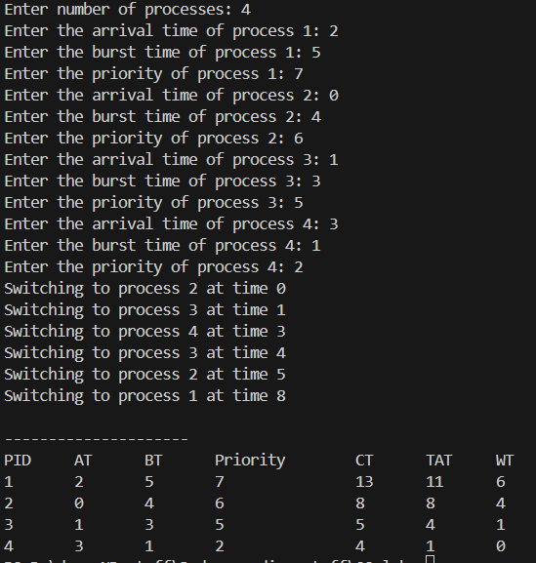

***NON-PREEMPTIVE PRIORITY SCHEDULING***

**CODE**

*#include* <stdio.h>

*#include* <stdbool.h>

*#include* <limits.h>

*typedef* *struct* process

{

*int* *pid*;

*int* *arrival_time*;

*int* *burst_time*;

*int* *completion_time*;

*int* *turn_around_time*;

*int* *waiting_time*;

*int* *priority*;

*bool* *completed*;

} process;

*void* *getProcessInfo*(process p*[]*, *int* n)

{

*for* (*int* *i* *=* 0; *i* *<* n; *i++*)

{

*printf*("Enter the Arrival time, Burst time and Priority of process %d: ", *i* *+* 1);

*scanf*("%d %d %d", *&*p[*i*].*arrival_time*, *&*p[*i*].*burst_time*, *&*p[*i*].*priority*);

p[*i*].*pid* *=* *i* *+* 1;

p[*i*].*completed* *=* *false*;

}

}

*int* *main*()

{

*printf*("\nLOWER PRIORITY VALUE HAS HIGHER PRIORITY\n");

*int* *n*;

*float* *avg_tat* *=* 0.0, *avg_wt* *=* 0.0;

*printf*("Enter number of processes: ");

*scanf*("%d", *&n*);

process *p*[*n*];

*getProcessInfo*(*p*, *n*);

*int* *current_time* *=* 0, *completed* *=* 0;

*while* (*completed* *<* *n*)

{

*int* *highest_priority_index* *=* *-*1;

*int* *highest_priority* *=* *INT_MAX*;

*for* (*int* *i* *=* 0; *i* *<* *n*; *i++*)

{

*if* (*p*[*i*].*arrival_time* *<=* *current_time* *&&* *!p*[*i*].*completed*)

{

*if* (*p*[*i*].*priority* *<* *highest_priority*)

{

*highest_priority* *=* *p*[*i*].*priority*;

*highest_priority_index* *=* *i*;

}

*else* *if* (*p*[*i*].*priority* *==* *highest_priority* *&&* *p*[*i*].*arrival_time* *<* *p*[*highest_priority_index*].*arrival_time*)

{

*highest_priority_index* *=* *i*;

}

}

}

*if* (*highest_priority_index* *!=* *-*1)

{

*int* *idx* *=* *highest_priority_index*;

*current_time* *+=* *p*[*idx*].*burst_time*;

*p*[*idx*].*completion_time* *=* *current_time*;

*p*[*idx*].*turn_around_time* *=* *p*[*idx*].*completion_time* *-* *p*[*idx*].*arrival_time*;

*p*[*idx*].*waiting_time* *=* *p*[*idx*].*turn_around_time* *-* *p*[*idx*].*burst_time*;

*p*[*idx*].*completed* *=* *true*;

*completed++*;

}

*else*

{

*current_time++*;

}

}

*for* (*int* *i* *=* 0; *i* *<* *n*; *i++*)

{

*avg_wt* *+=* *p*[*i*].*waiting_time*;

*avg_tat* *+=* *p*[*i*].*turn_around_time*;

}

*printf*("\n---------------------------------------------------------------------------------------------------------\n");

*printf*("Process ID\tArrival Time\tBurst Time\tPriority\tCompletion Time\tTurnAround Time\tWaiting Time\n");

*for* (*int* *i* *=* 0; *i* *<* *n*; *i++*)

{

*printf*(" %d\t\t\t%d\t\t%d\t\t%d\t\t%d\t\t%d\t\t%d\n", *p*[*i*].*pid*, *p*[*i*].*arrival_time*, *p*[*i*].*burst_time*, *p*[*i*].*priority*, *p*[*i*].*completion_time*, *p*[*i*].*turn_around_time*, *p*[*i*].*waiting_time*);

}

*printf*("\n");

*printf*("\nAverage Turn-Around Time = %.2f units ", *avg_tat* */* *n*);

*printf*("\nAverage Waiting Time = %.2f units ", *avg_wt* */* *n*);

*return* 0;

}

**OUTPUT**

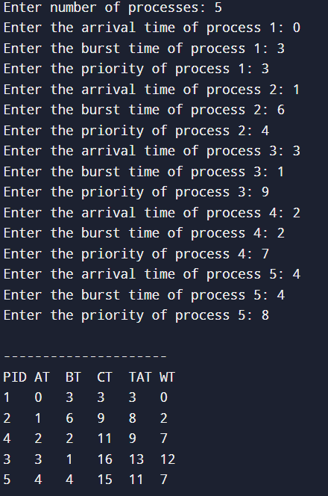

**LEARNING OUTCOMES**

**PROGRAM - 6**

**PROBLEM STATEMENT Write a program to implement first fit, best fit and worst fit algorithm for memory management.**

**THEORY**

First Fit, Best Fit, and Worst Fit are memory management algorithms used in operating systems to allocate memory blocks to processes. Each approach has unique strategies to allocate free memory, balancing between minimising fragmentation and maximising resource utilisation.

**First Fit Algorithm**

The first-fit algorithm searches for the first free partition that is large enough to accommodate the process. The operating system starts searching from the beginning of the memory and allocates the first free partition that is large enough to fit the process.

**Best Fit Algorithm**

The best-fit algorithm searches for the smallest free partition that is large enough to accommodate the process. The operating system searches the entire memory and selects the free partition that is closest in size to the process.

**Worst Fit Algorithm**

The worst-fit algorithm searches for the largest free partition and allocates the process to it. This algorithm is designed to leave the largest possible free partition for future use.

**ALGORITHM**

**NUMERICAL**

**Given five memory partitions of 100Kb, 500Kb, 200Kb, 300Kb, 600Kb (in order), how would the first-fit, best-fit, and worst-fit algorithms place processes of 212 Kb, 417 Kb, 112 Kb, and 426 Kb (in order)? Which algorithm makes the most efficient use of memory?**

|  |  |  |  |  |  |
| --- | --- | --- | --- | --- | --- |
| **Memory Block** | 100 KB | 500 KB | 200 KB | 300 KB | 600KB |
| **Processes** | 212 KB **(P1)** | 417KB **(P2)** | 112 KB **(P3)** | 426 KB **(P4)** |  |

**CODE**

*#include* <stdio.h>

*void* *firstFit*(*int* blockSize*[]*, *int* m, *int* processSize*[]*, *int* n)

{

*int* *allocation*[n];

*for* (*int* *i* *=* 0; *i* *<* n; *i++*)

*allocation*[*i*] *=* *-*1;

*for* (*int* *i* *=* 0; *i* *<* n; *i++*)

{

*for* (*int* *j* *=* 0; *j* *<* m; *j++*)

{

*if* (blockSize[*j*] *>=* processSize[*i*])

{

*allocation*[*i*] *=* *j*;

blockSize[*j*] *-=* processSize[*i*];

*break*;

}

}

}

*printf*("\nFirst Fit Allocation:\nProcess No.\tProcess Size\tBlock No.\n");

*for* (*int* *i* *=* 0; *i* *<* n; *i++*)

{

*printf*("%d\t\t%d\t\t", *i* *+* 1, processSize[*i*]);

*if* (*allocation*[*i*] *!=* *-*1)

*printf*("%d\n", *allocation*[*i*] *+* 1);

*else*

*printf*("Not Allocated\n");

}

}

*void* *bestFit*(*int* blockSize*[]*, *int* m, *int* processSize*[]*, *int* n)

{

*int* *allocation*[n];

*for* (*int* *i* *=* 0; *i* *<* n; *i++*)

*allocation*[*i*] *=* *-*1;

*for* (*int* *i* *=* 0; *i* *<* n; *i++*)

{

*int* *bestIdx* *=* *-*1;

*for* (*int* *j* *=* 0; *j* *<* m; *j++*)

{

*if* (blockSize[*j*] *>=* processSize[*i*])

{

*if* (*bestIdx* *==* *-*1 *||* blockSize[*j*] *<* blockSize[*bestIdx*])

*bestIdx* *=* *j*;

}

}

*if* (*bestIdx* *!=* *-*1)

{

*allocation*[*i*] *=* *bestIdx*;

blockSize[*bestIdx*] *-=* processSize[*i*];

}

}

*printf*("\nBest Fit Allocation:\nProcess No.\tProcess Size\tBlock No.\n");

*for* (*int* *i* *=* 0; *i* *<* n; *i++*)

{

*printf*("%d\t\t%d\t\t", *i* *+* 1, processSize[*i*]);

*if* (*allocation*[*i*] *!=* *-*1)

*printf*("%d\n", *allocation*[*i*] *+* 1);

*else*

*printf*("Not Allocated\n");

}

}

*void* *worstFit*(*int* blockSize*[]*, *int* m, *int* processSize*[]*, *int* n)

{

*int* *allocation*[n];

*for* (*int* *i* *=* 0; *i* *<* n; *i++*)

*allocation*[*i*] *=* *-*1;

*for* (*int* *i* *=* 0; *i* *<* n; *i++*)

{

*int* *worstIdx* *=* *-*1;

*for* (*int* *j* *=* 0; *j* *<* m; *j++*)

{

*if* (blockSize[*j*] *>=* processSize[*i*])

{

*if* (*worstIdx* *==* *-*1 *||* blockSize[*j*] *>* blockSize[*worstIdx*])

*worstIdx* *=* *j*;

}

}

*if* (*worstIdx* *!=* *-*1)

{

*allocation*[*i*] *=* *worstIdx*;

blockSize[*worstIdx*] *-=* processSize[*i*];

}

}

*printf*("\nWorst Fit Allocation:\nProcess No.\tProcess Size\tBlock No.\n");

*for* (*int* *i* *=* 0; *i* *<* n; *i++*)

{

*printf*("%d\t\t%d\t\t", *i* *+* 1, processSize[*i*]);

*if* (*allocation*[*i*] *!=* *-*1)

*printf*("%d\n", *allocation*[*i*] *+* 1);

*else*

*printf*("Not Allocated\n");

}

}

*int* *main*()

{

*int* *m*, *n*;

*printf*("Enter the number of blocks: ");

*scanf*("%d", *&m*);

*int* *blockSize*[*m*];

*printf*("Enter the sizes of the blocks:\n");

*for* (*int* *i* *=* 0; *i* *<* *m*; *i++*)

*scanf*("%d", *&blockSize*[*i*]);

*printf*("Enter the number of processes: ");

*scanf*("%d", *&n*);

*int* *processSize*[*n*];

*printf*("Enter the sizes of the processes:\n");

*for* (*int* *i* *=* 0; *i* *<* *n*; *i++*)

*scanf*("%d", *&processSize*[*i*]);

*int* *blockSize1*[*m*], *blockSize2*[*m*], *blockSize3*[*m*];

*for* (*int* *i* *=* 0; *i* *<* *m*; *i++*)

{

*blockSize1*[*i*] *=* *blockSize*[*i*];

*blockSize2*[*i*] *=* *blockSize*[*i*];

*blockSize3*[*i*] *=* *blockSize*[*i*];

}

*firstFit*(*blockSize1*, *m*, *processSize*, *n*);

*bestFit*(*blockSize2*, *m*, *processSize*, *n*);

*worstFit*(*blockSize3*, *m*, *processSize*, *n*);

*return* 0;

}

**OUTPUT:**

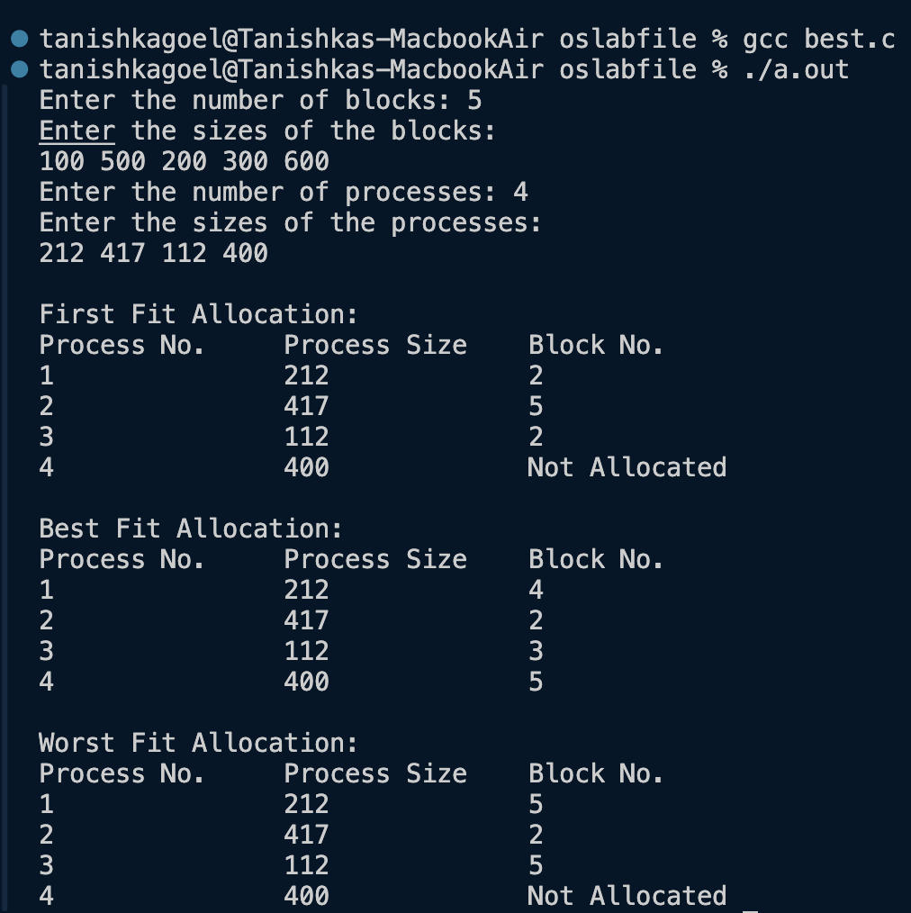

**LEARNING OUTCOMES**

**PROGRAM - 7**

**PROBLEM STATEMENT Write a program to implement reader/writer problem using semaphore.**

**THEORY**

The **Reader-Writer Problem** is a classic synchronization problem in computer science, which deals with allowing multiple processes to access a shared resource (like a database) while preventing data inconsistency. The problem is particularly useful in operating systems and databases where processes (or threads) need to read or write shared data.

In the Reader-Writer problem, there are two types of processes:

1. **Readers**: Processes that only read the shared data. Multiple readers can access the data simultaneously without causing inconsistencies.
2. **Writers**: Processes that modify (write to) the shared data. Only one writer can access the data at a time to avoid data corruption.

**Problem Statement**

The challenge in the Reader-Writer Problem is to design a system that:

* Allows multiple readers to read simultaneously.
* Restricts writers so that only one writer can access the shared data at a time.
* Prevents readers from accessing the data while a writer is modifying it.

There are two main variations of the problem:

1. **First Reader-Writers Problem (No Starvation for Readers)**: This version gives priority to readers, allowing them to read as long as there is no writer waiting.
2. **Second Reader-Writers Problem (No Starvation for Writers)**: This version gives priority to writers, ensuring that once a writer is waiting, no new readers can start reading until the writer has finished.

**Solution Using Semaphores**

Semaphores are used to implement synchronisation and avoid race conditions in the Reader-Writer Problem. Here, we commonly use three semaphores:

1. **mutex**: Ensures mutual exclusion when modifying the count of readers.
2. **wrt**: Controls access to the shared resource, ensuring mutual exclusion for writers.
3. **read_count**: Keeps track of the number of readers currently accessing the shared resource.

**Semaphores:**

* mutex and wrt are binary semaphores, which can take the values 0 or 1.
* read_count is an integer variable, protected by mutex, to keep track of the number of active readers.

**ALGORITHM**

**CODE**

*#include* <stdio.h>

*#include* <stdlib.h>

*#include* <unistd.h>

*#include* <pthread.h>

*pthread_mutex_t* *x* *=* *PTHREAD_MUTEX_INITIALIZER*;

*pthread_mutex_t* *y* *=* *PTHREAD_MUTEX_INITIALIZER*;

*pthread_cond_t* *cond* *=* *PTHREAD_COND_INITIALIZER*;

*int* *readercount* *=* 0;

*int* *writercount* *=* 0;

*void* *\*reader*(*void* *\**param) {

*int* *reader_id* *=* *\**((*int* *\**)param);

*pthread_mutex_lock*(*&x*);

*readercount++*;

*if* (*readercount* *==* 1) {

*pthread_mutex_lock*(*&y*);

*}*

*pthread_mutex_unlock*(*&x*);

*printf*("Reader %d is reading data\n", *reader_id*);

*usleep*(100000);

*printf*("Reader %d is done reading\n", *reader_id*);

*pthread_mutex_lock*(*&x*);

*readercount--*;

*printf*("Reader %d is leaving. Remaining readers: %d\n", *reader_id*, *readercount*);

*if* (*readercount* *==* 0) {

*pthread_mutex_unlock*(*&y*);

*}*

*pthread_mutex_unlock*(*&x*);

*return* *NULL*;

}

*void* *\*writer*(*void* *\**param) {

*int* *writer_id* *=* *\**((*int* *\**)param);

*printf*("Writer %d is trying to enter\n", *writer_id*);

*pthread_mutex_lock*(*&y*);

*printf("Writer %d is writing data\n", writer_id);*

*usleep*(200000);

*printf("Writer %d is done writing\n", writer_id);*

*pthread_mutex_unlock*(*&y*);

*return* *NULL*;

}

*int* *main*() {

*int* *n2*, *i*;

*printf*("Enter the number of readers and writers: ");

*scanf*("%d", *&n2*);

*printf*("\n");

*pthread_t* *readerthreads*[*n2*], *writerthreads*[*n2*];

*int* *reader_ids*[*n2*], *writer_ids*[*n2*];

*for (i = 0; i < n2; i++) {*

*reader_ids*[*i*] *=* *i* *+* 1;

*writer_ids*[*i*] *=* *i* *+* 1;

*pthread_create*(*&readerthreads*[*i*], *NULL*, *reader*, *&reader_ids*[*i*]);

*pthread_create*(*&writerthreads*[*i*], *NULL*, *writer*, *&writer_ids*[*i*]);

}

*for (i = 0; i < n2; i++) {*

*pthread_join*(*readerthreads*[*i*], *NULL*);

*pthread_join*(*writerthreads*[*i*], *NULL*);

}

*pthread_mutex_destroy*(*&x*);

*pthread_mutex_destroy*(*&y*);

*return* 0;

}

**OUTPUT**

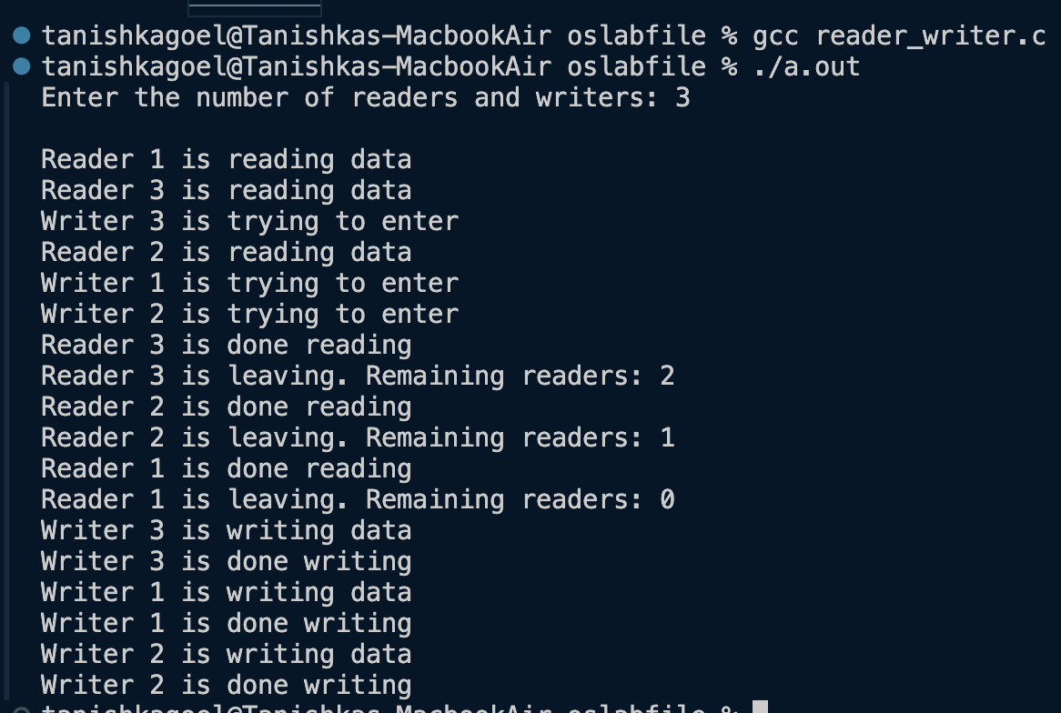**LEARNING OUTCOMES**

**PROGRAM - 8**

**PROBLEM STATEMENT Write a program to implement Producer‐Consumer problem using semaphores.**

**THEORY**

The Producer-Consumer problem is a classic synchronization issue in operating systems. It involves two types of processes: producers, which generate data, and consumers, which process that data. Both share a common buffer.

**Problem Statement**

The challenge is to ensure that the producer doesn’t add data to a full buffer and the consumer doesn’t remove data from an empty buffer while avoiding conflicts when accessing the buffer.

**Semaphore**

A semaphore is a synchronization tool used in computing to manage access to shared resources. It works like a signal that allows multiple processes or threads to coordinate their actions. Semaphores use counters to keep track of how many resources are available, ensuring that no two processes can use the same resource at the same time, thus preventing conflicts and ensuring orderly execution.

In the Producer-Consumer Problem, three semaphores are typically employed:

1. **mutex**: Ensures mutual exclusion, allowing only one process to access the buffer at a time. This avoids simultaneous read/write operations by multiple producers or consumers.
2. **empty**: Counts the number of empty slots available in the buffer, ensuring that the producer only produces when there is space available.
3. **full**: Counts the number of filled slots in the buffer, ensuring that the consumer only consumes when there is data available.

**Solution Using Semaphores**

Each producer and consumer action is governed by conditions enforced by the semaphores. The basic idea is:

**Producer Process:**

Waits on the empty semaphore to check if there’s space in the buffer.

Waits on mutex to get exclusive access to the buffer and produce an item.

Signals full after producing an item to indicate that there is now one more item for the consumer to consume.

**Consumer Process:**

Waits on the full semaphore to check if there’s an item to consume.

Waits on mutex to get exclusive access to the buffer and consume an item.

Signals empty after consuming an item to indicate there is now one more empty slot for the producer.

**ALGORITHM**

**CODE**

*#include* <stdio.h>

*#include* <stdlib.h>

*int* *mutex* *=* 1;

*int* *full* *=* 0;

*int* *empty*, *x* *=* 0;

*void* *producer*() {

*--mutex*;

*++full*;

*--empty*;

*x++*;

*printf*("Producer produces item %d\n", *x*);

*++mutex*;

}

*void* *consumer*() {

*--mutex*;

*--full*;

*++empty*;

*printf*("Consumer consumes item %d\n", *x*);

*x--*;

*++mutex*;

}

*void* *showBuffer*() {

*printf*("\nBuffer Status:");

*printf*("\nFull slots: %d", *full*);

*printf*("\nEmpty slots: %d", *empty*);

*printf*("\nTotal items in buffer: %d\n", *x*);

}

*int* *main*() {

*int* *n*, *bufferSize*;

*printf*("Enter buffer size: ");

*scanf*("%d", *&bufferSize*);

*empty* *=* *bufferSize*;

*printf*("\n1. Press 1 for Producer"

"\n2. Press 2 for Consumer"

"\n3. Press 3 for Exit"

"\n4. Press 4 to Show Buffer Status");

*while* (1) {

*printf*("\nEnter your choice: ");

*scanf*("%d", *&n*);

*switch* (*n*) {

*case* 1:

*if* (*mutex* *==* 1 *&&* *empty* *!=* 0) {

*producer*();

} *else* {

*printf*("Buffer is full!\n");

}

*break*;

*case* 2:

*if* (*mutex* *==* 1 *&&* *full* *!=* 0) {

*consumer*();

} *else* {

*printf*("Buffer is empty!\n");

}

*break*;

*case* 3:

*exit*(0);

*break*;

*case* 4:

*showBuffer*();

*break*;

*default*:

*printf*("Invalid choice! Please try again.");

}

}

}

**OUTPUT**

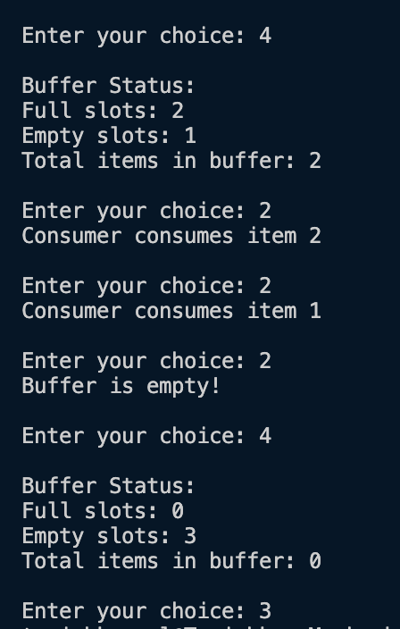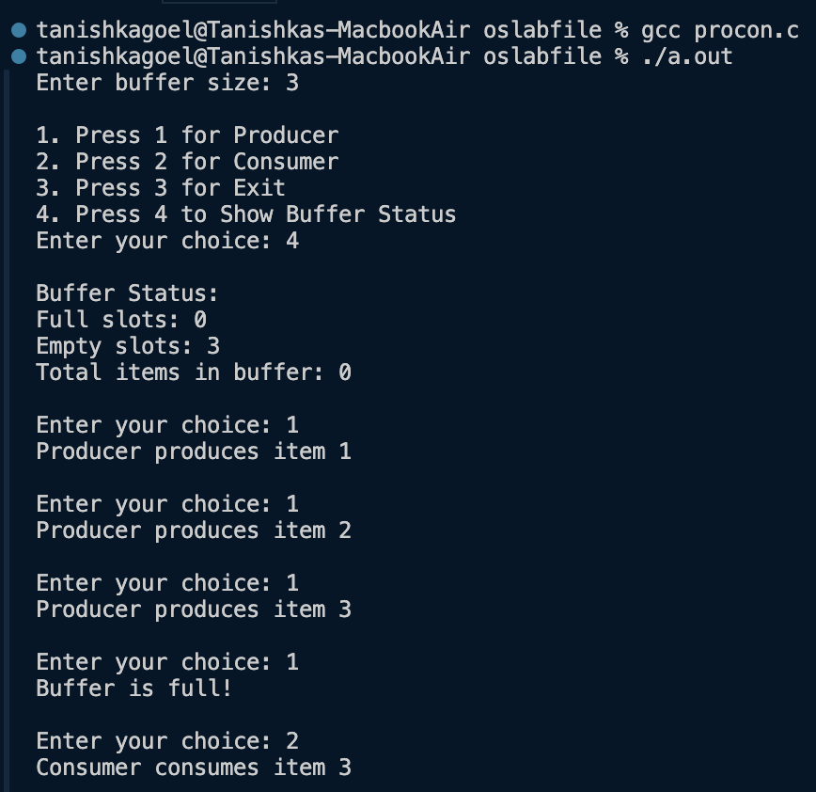

**LEARNING OUTCOMES**

**PROGRAM - 9**

**PROBLEM STATEMENT Write a program to implement Banker’s algorithm for deadlock avoidance.**

**THEORY**

The Banker’s Algorithm is a deadlock avoidance algorithm introduced by Edsger Dijkstra, designed to handle resource allocation in systems where multiple processes compete for limited resources. Named after a banking system analogy, it helps determine if a system can safely allocate resources to processes without running into a deadlock.

**Key Concepts in Banker's Algorithm**

1. **Safe State**: A system is in a "safe state" if there is a sequence in which processes can complete their execution without running into deadlock. In this state, each process can eventually receive the resources it needs and finish, releasing those resources back to the system.
2. **Unsafe State**: If there’s no safe sequence that can ensure the successful completion of all processes, the system is in an "unsafe state." An unsafe state may lead to a deadlock, but it doesn’t necessarily mean a deadlock has occurred yet.
3. **Resource Allocation**: Banker’s Algorithm works by keeping track of allocated resources, available resources, and maximum resources needed by each process, and dynamically makes decisions about resource allocation based on these values.

**Working of Banker's Algorithm**

The algorithm operates under the assumption that each process must declare the maximum number of resources it might need. Based on this information, the system decides whether to grant a process's resource request by simulating the allocation and checking if the resulting state is safe.

The algorithm requires three main data structures:

* **Available**: A vector that represents the number of resources of each type currently available in the system.
* **Max**: A matrix where each row represents a process and each column represents the maximum number of resources of a particular type that a process may request.
* **Allocation**: A matrix that represents the number of resources of each type currently allocated to each process.
* **Need**: A matrix calculated by subtracting Allocation from Max for each process, representing the remaining resources each process will need to complete.

**ALGORITHM**

**CODE**

*#include* <stdio.h>

*#define* *MAX* 5

*int* *available*[*MAX*], *max*[*MAX*][*MAX*], *allocation*[*MAX*][*MAX*], *need*[*MAX*][*MAX*], *n*, *m*;

*void* *calculateNeed*()

{

*for* (*int* *i* *=* 0; *i* *<* *n*; *i++*)

*for* (*int* *j* *=* 0; *j* *<* *m*; *j++*)

*need*[*i*][*j*] *=* *max*[*i*][*j*] *-* *allocation*[*i*][*j*];

}

*int* *checkSafeState*()

{

*int* *work*[*MAX*], *finish*[*MAX*] *=* {0}, *safeSequence*[*MAX*], *count* *=* 0;

*for* (*int* *i* *=* 0; *i* *<* *m*; *i++*)

*work*[*i*] *=* *available*[*i*];

*while* (*count* *<* *n*)

{

*int* *found* *=* 0;

*for* (*int* *i* *=* 0; *i* *<* *n*; *i++*)

{

*if* (*finish*[*i*] *==* 0)

{

*int* *j*;

*for* (*j* *=* 0; *j* *<* *m*; *j++*)

*if* (*need*[*i*][*j*] *>* *work*[*j*])

*break*;

*if* (*j* *==* *m*)

{

*for* (*int* *k* *=* 0; *k* *<* *m*; *k++*)

*work*[*k*] *+=* *allocation*[*i*][*k*];

*safeSequence*[*count++*] *=* *i*;

*finish*[*i*] *=* 1;

*found* *=* 1;

}

}

}

*if* (*found* *==* 0)

{

*printf*("System is not in a safe state.\n");

*return* 0;

}

}

*printf*("System is in a safe state.\nSafe sequence is: ");

*for* (*int* *i* *=* 0; *i* *<* *n*; *i++*)

{

*printf*("%d ", *safeSequence*[*i*]);

}

*printf*("\n");

*return* 1;

}

*int* *main*()

{

*printf*("Enter the number of processes: ");

*scanf*("%d", *&n*);

*printf*("Enter the number of resources: ");

*scanf*("%d", *&m*);

*printf*("Enter available resources: ");

*for* (*int* *i* *=* 0; *i* *<* *m*; *i++*)

{

*printf*("Resource %d: ", *i* *+* 1);

*scanf*("%d", *&available*[*i*]);

}

*printf*("Enter maximum resources for each process:\n");

*for* (*int* *i* *=* 0; *i* *<* *n*; *i++*)

{

*printf*("Enter maximum resources for process %d: ", *i* *+* 1);

*for* (*int* *j* *=* 0; *j* *<* *m*; *j++*)

{

*scanf*("%d", *&max*[*i*][*j*]);

}

}

*printf*("Enter allocated resources for each process:\n");

*for* (*int* *i* *=* 0; *i* *<* *n*; *i++*)

{

*printf*("Enter allocated resources for process %d: ", *i* *+* 1);

*for* (*int* *j* *=* 0; *j* *<* *m*; *j++*)

{

*scanf*("%d", *&allocation*[*i*][*j*]);

}

}

*calculateNeed*();

*checkSafeState*();

*return* 0;

}

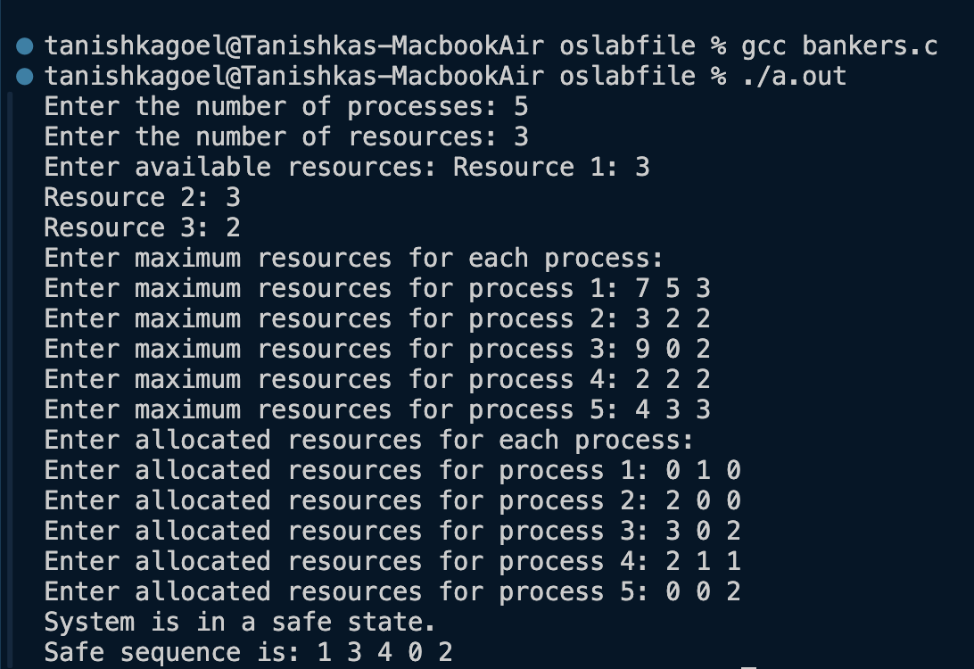**OUTPUT**

**LEARNING OUTCOMES**

**PROGRAM - 10**

**PROBLEM STATEMENT Write C programs to implement the various File Organisation Techniques**

**THEORY**

File organization techniques in an operating system (OS) refer to methods used to store, manage, and access files on storage devices efficiently. Different techniques offer varying advantages depending on the requirements for quick access, minimal fragmentation, and easy maintenance. Here are the main file organization techniques:

**Sequential Access**

Sequential access is a file organization method where records are stored in a specific order, one after another, typically based on a key or a logical sequence. This organization is simple and commonly used for files that need to be processed in sequence, such as logs or transaction files. With sequential access, data is read or written starting from the beginning of the file, making it ideal for batch processing tasks where records are accessed in order.

**Direct (or Hashed) Access**

Direct, or hashed, access organizes records by computing their storage location using a hashing function, which maps a record’s key directly to a specific address in memory or on disk. This method allows for rapid retrieval, as it enables direct access to a record without reading intervening records, making it efficient for applications where records need to be accessed frequently or randomly. When a record is needed, the hashing function is applied to its key, quickly locating the exact storage location.

**Indexed File Organization**

Indexed file organization improves random access by using an index, similar to a book’s table of contents, which maintains pointers to the locations of records within the file. The index is typically built based on one or more key fields, and each entry in the index corresponds to a unique record in the file, containing both the key and the record’s address. This organization enables efficient access to records by allowing direct retrieval of the desired record through the index without reading the entire file. Indexed files support both sequential and random access, making them versatile for a variety of applications. They are particularly advantageous when there is a need to frequently search for, insert, or delete records.

**ALGORITHM**

**CODE**

*#include* <stdio.h>

*#include* <stdlib.h>

*#include* <string.h>

*#define* *MAX_RECORDS* 100

*#define* *NAME_LENGTH* 20

*typedef* *struct* {

*int* *id*; *// Unique identifier for the record*

*char* *name*[*NAME_LENGTH*]; *// Name associated with the record*

} Record;

*void* *writeIndexed*();

*void* *readIndexed*();

*void* *writeHashed*();

*void* *readHashed*();

*void* *writeSequential*();

*void* *readSequential*();

*int* *main*() {

*int* *choice*;

*while* (1) {

*printf*("\n1. Write Indexed File");

*printf*("\n2. Read Indexed File");

*printf*("\n3. Write Hashed File");

*printf*("\n4. Read Hashed File");

*printf*("\n5. Write Sequential File");

*printf*("\n6. Read Sequential File");

*printf*("\n7. Exit");

*printf*("\nEnter your choice: ");

*scanf*("%d", *&choice*);

*switch* (*choice*) {

*case* 1:

*writeIndexed*();

*break*;

*case* 2:

*readIndexed*();

*break*;

*case* 3:

*writeHashed*();

*break*;

*case* 4:

*readHashed*();

*break*;

*case* 5:

*writeSequential*();

*break*;

*case* 6:

*readSequential*();

*break*;

*case* 7:

*exit*(0);

*default*:

*printf*("Invalid choice. Please try again.");

}

}

*return* 0;

}

*void* *writeIndexed*() {

FILE *\*file* *=* *fopen*("indexed.txt", "w");

FILE *\*indexFile* *=* *fopen*("index.txt", "w");

*if* (*!file* *||* *!indexFile*) {

*printf*("Error opening file!\n");

*return*;

}

Record *records*[*MAX_RECORDS*];

*int* *recordCount* *=* 0;

*char* *addMore*;

*do* {

*printf*("Enter ID: ");

*scanf*("%d", *&records*[*recordCount*].*id*);

*printf*("Enter Name: ");

*scanf*("%s", *records*[*recordCount*].*name*);

*recordCount++*;

*printf*("Do you want to add another record? (y/n): ");

*scanf*(" %c", *&addMore*);

} *while* (*addMore* *==* 'y' *&&* *recordCount* *<* *MAX_RECORDS*);

*for* (*int* *i* *=* 0; *i* *<* *recordCount*; *i++*) {

*fprintf*(*file*, "%d %s\n", *records*[*i*].*id*, *records*[*i*].*name*); *// Write the record*

*fprintf*(*indexFile*, "%d %ld\n", *records*[*i*].*id*, *ftell*(*file*) *-* *sizeof*(Record)); *// Write ID and position to index*

}

*fclose*(*file*);

*fclose*(*indexFile*);

*printf*("Records written to indexed.txt and index.txt.\n");

}

*void* *readIndexed*() {

FILE *\*file* *=* *fopen*("indexed.txt", "r");

FILE *\*indexFile* *=* *fopen*("index.txt", "r");

*if* (*!file* *||* *!indexFile*) {

*printf*("Error opening file!\n");

*return*;

}

Record *record*;

*printf*("\nIndexed Records:\n");

*while* (*fscanf*(*file*, "%d %s", *&record*.*id*, *record*.*name*) *!=* *EOF*) {

*printf*("ID: %d, Name: %s\n", *record*.*id*, *record*.*name*);

}

*fclose*(*file*);

*fclose*(*indexFile*);

}

*void* *writeHashed*() {

FILE *\*file* *=* *fopen*("hashed.txt", "a");

*if* (*!file*) {

*printf*("Error opening file!\n");

*return*;

}

Record *records*[*MAX_RECORDS*];

*int* *recordCount* *=* 0;

*char* *addMore*;

*do* {

*printf*("Enter ID: ");

*scanf*("%d", *&records*[*recordCount*].*id*);

*printf*("Enter Name: ");

*scanf*("%s", *records*[*recordCount*].*name*);

*recordCount++*;

*printf*("Do you want to add another record? (y/n): ");

*scanf*(" %c", *&addMore*);

} *while* (*addMore* *==* 'y' *&&* *recordCount* *<* *MAX_RECORDS*);

*for* (*int* *i* *=* 0; *i* *<* *recordCount*; *i++*) {

*fprintf*(*file*, "%d %s\n", *records*[*i*].*id*, *records*[*i*].*name*); *// Write the record*

}

*fclose*(*file*);

*printf*("Records written to hashed.txt.\n");

}

*void* *readHashed*() {

FILE *\*file* *=* *fopen*("hashed.txt", "r");

*if* (*!file*) {

*printf*("Error opening file!\n");

*return*;

}

Record *record*;

*printf*("\nHashed Records:\n");

*while* (*fscanf*(*file*, "%d %s", *&record*.*id*, *record*.*name*) *!=* *EOF*) {

*printf*("ID: %d, Name: %s\n", *record*.*id*, *record*.*name*);

}

*fclose*(*file*);

}

*void* *writeSequential*() {

FILE *\*file* *=* *fopen*("sequential.txt", "a");

*if* (*!file*) {

*printf*("Error opening file!\n");

*return*;

}

Record *records*[*MAX_RECORDS*];

*int* *recordCount* *=* 0;

*char* *addMore*;

*do* {

*printf*("Enter ID: ");

*scanf*("%d", *&records*[*recordCount*].*id*);

*printf*("Enter Name: ");

*scanf*("%s", *records*[*recordCount*].*name*);

*recordCount++*;

*printf*("Do you want to add another record? (y/n): ");

*scanf*(" %c", *&addMore*);

} *while* (*addMore* *==* 'y' *&&* *recordCount* *<* *MAX_RECORDS*);

*for* (*int* *i* *=* 0; *i* *<* *recordCount*; *i++*) {

*fprintf*(*file*, "%d %s\n", *records*[*i*].*id*, *records*[*i*].*name*); *// Write the record*

}

*fclose*(*file*);

*printf*("Records written to sequential.txt.\n");

}

*void* *readSequential*() {

FILE *\*file* *=* *fopen*("sequential.txt", "r");

*if* (*!file*) {

*printf*("Error opening file!\n");

*return*;

}

Record *record*;

*printf*("\nSequential Records:\n");

*while* (*fscanf*(*file*, "%d %s", *&record*.*id*, *record*.*name*) *!=* *EOF*) {

*printf*("ID: %d, Name: %s\n", *record*.*id*, *record*.*name*);

}

*fclose*(*file*);

}

**OUTPUT**

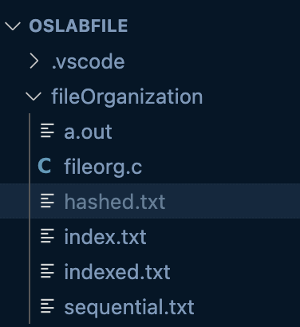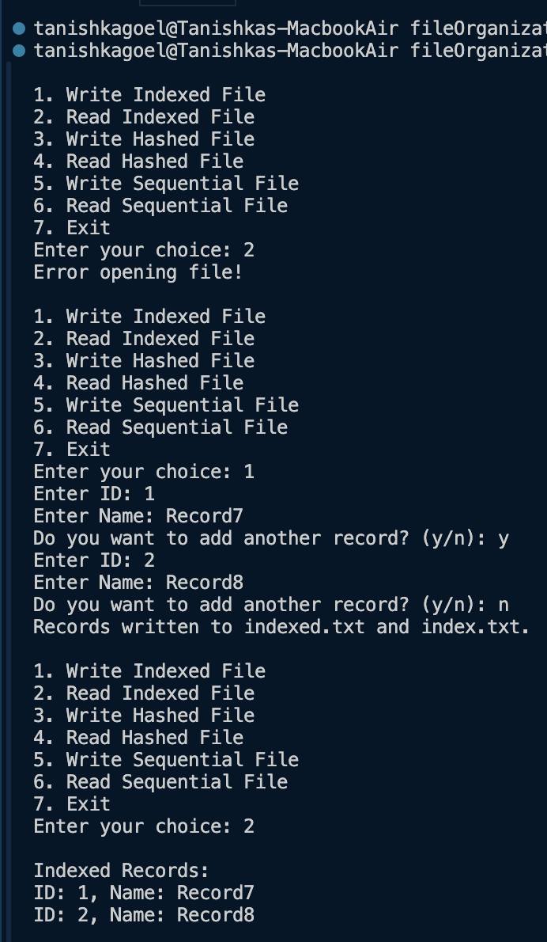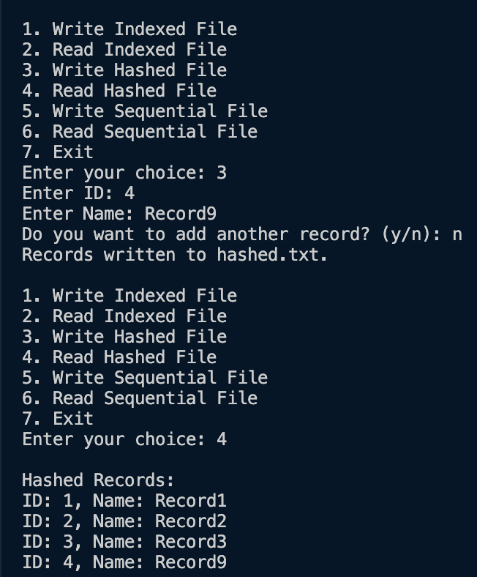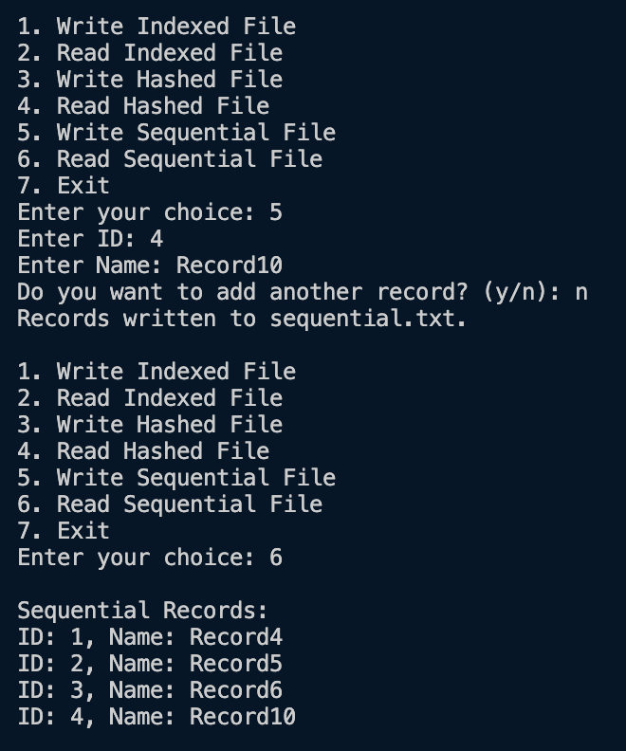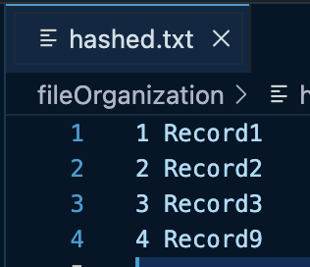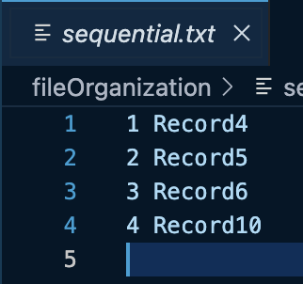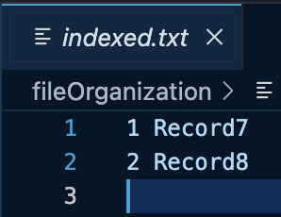

**LEARNING OUTCOMES**